3VR

Migrating Appliance and Enterprise Phase I

Software Design Document

Name (s): Jackie.zhang@3vr.com

Lab Section:

Workstation:

Date: (02/26/2016)

|  |  |  |  |  |
| --- | --- | --- | --- | --- |
| Date | Version | Originator/Reviewer | Comments | Remarks |
| 02/26/2016 | 0.1 | Jackie. Zhang | Initial Draft |  |
|  |  |  |  |  |
|  |  |  |  |  |
|  |  |  |  |  |
|  |  |  |  |  |
|  |  |  |  |  |
|  |  |  |  |  |
|  |  |  |  |  |
|  |  |  |  |  |
|  |  |  |  |  |

**TABLE OF CONTENTS**

1. INTRODUCTION 1

2. SYSTEM OVERVIEW 1

3. SYSTEM ARCHITECTURE 1

3.1 Architectural Design 1

3.2 Decomposition Description 1

4. DATA DESIGN 10

5. HUMAN INTERFACE DESIGN 10

6. REQUIREMENTS MATRIX 10

7. Error Conditions 10

8. APPENDICES 10

1. INTRODUCTION

This document describes the architecture and system design of 3VR Migrating Appliance and enterprise Phase I.

When customer upgrade old appliance to new appliance, there are lots of work to do, for example, they have to config all channels, install and config plugins, etc. So for easy setup new appliance to replace old appliance, we should make appliance be provided with migration ability.

1. SYSTEM OVERVIEW

Following are the requirement of 3VR Migrating Appliance and Enterprise Phase I:

1. Migrating to a new appliance by transferring from old appliance.
2. Migrating to a new Enterprise by transferring from old enterprise.
3. Requirements and assumptions
4. SYSTEM ARCHITECTURE
   1. Architectural Design
   2. Decomposition Description
      1. Only backup specified channel’s data files to ESS
         1. System Manager

In Configure Client Extended Storage Dialog, we add panel for select channels, please see below GUI:

. 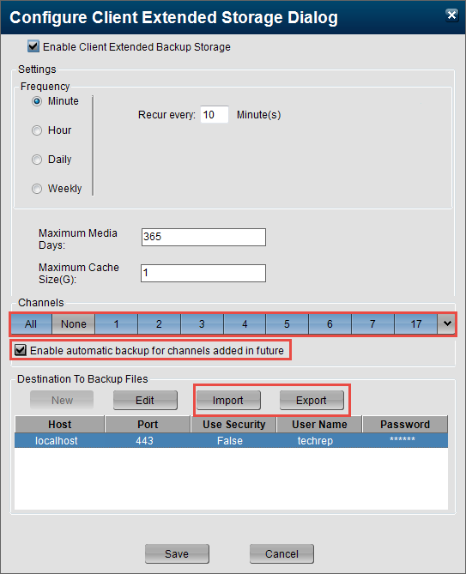

* + - 1. New table BackupDetails

We need a new table ‘BackupDetails’ to store the backup details about specified channels, because maybe some channels are not specified at the same time.

|  |  |  |
| --- | --- | --- |
| **BackupDetails** | | |
| ChannleId | IsActive | BackupEndTime |
|  |  |  |

Following is the details for each column:

ChannleId: primary key, it is use to indicate specified channel.

IsActive: it is use to indicate whether continue backup this channel’s data.

BackupEndTime: the latest backup video file timestamp of this channel. It is used to indicate whether this channel is new added.

If its value is less than the EndTime of BackupSummary that is means this channel is new added.

After click Save button of Configure Client Extended Storage Dialog, we will add or modify selected channels in BackupDetails table.

For example, at beginning, the BackupSummary and BackupDetails are empty.

|  |  |  |  |
| --- | --- | --- | --- |
| **BackupSummary** | | | |
| BackupSummaryId | BackupDestId | BeginTime | EndTime |
|  |  |  |  |

|  |  |  |
| --- | --- | --- |
| **BackupDetails** | | |
| ChannleId | IsActive | BackupEndTime |
|  |  |  |
|  |  |  |
|  |  |  |

**Then specify channel 1 to backup**. Add new record to BackupDetails

|  |  |  |
| --- | --- | --- |
| **BackupDetails** | | |
| ChannleId | IsActive | BackupEndTime |
| 1 | 1 | DateTime.MinValue |
|  |  |  |
|  |  |  |

After channel 1 backup sometimes then **add channel 2 to backup**.

|  |  |  |  |
| --- | --- | --- | --- |
| **BackupSummary** | | | |
| BackupSummaryId | BackupDestId | BeginTime | EndTime |
| 1 | 1 | 2014/12/06 09:25:34 | 2014/12/07 11:25:30 |

|  |  |  |
| --- | --- | --- |
| **BackupDetails** | | |
| ChannleId | IsActive | BackupEndTime |
| 1 | 1 | 2014/12/07 11:25:30 |
| 2 | 1 | DateTime.MinValue |
|  |  |  |

Note: because at first, all the selected channels’ BackupEndTime are equals the EndTime of BackupSummary.

After add channel 2 to backup, the backup timer will reset, and check whether channels are new added (BackupDetails. BackupEndTime < BackupSummary. EndTime), and found channel 2 is new added, so first backup channel2’

After channel2annel 2 is new added, so the table content should be like below:

|  |  |  |  |
| --- | --- | --- | --- |
| **BackupSummary** | | | |
| BackupSummaryId | BackupDestId | BeginTime | EndTime |
| 1 | 1 | 2014/12/06 09:25:34 | 2014/12/07 11:25:30 |

|  |  |  |
| --- | --- | --- |
| **BackupDetails** | | |
| ChannleId | IsActive | BackupEndTime |
| 1 | 1 | 2014/12/07 11:25:30 |
| 2 | 1 | 2014/12/07 11:25:30 |
|  |  |  |

Disable channel2 backup.

|  |  |  |  |
| --- | --- | --- | --- |
| **BackupSummary** | | | |
| BackupSummaryId | BackupDestId | BeginTime | EndTime |
| 1 | 1 | 2014/12/06 09:25:34 | 2014/12/07 11:25:30 |

|  |  |  |
| --- | --- | --- |
| **BackupDetails** | | |
| ChannleId | IsActive | BackupEndTime |
| 1 | 1 | 2014/12/07 11:25:30 |
| 2 | **0** | 2014/12/07 11:25:30 |
|  |  |  |

Note: not all the channel’ote: not all the channellike

* + - 1. Extended Storage Client API

Get the specified channel’s data file list between begin and end timestamp:

For videos:

Fetch specified channel’s file pathname list between begin time and end time stamp order by timestamp.

For audios:

Directly read subfolders on media storage devices. Because the audio storage folder structure is ‘date/hour/audio/channelNumber/filename’, we can filter folder name based on begin and end timestamp and get file list.

And then filter by channel number.

For images:

**Because all channel’s images stored in the same image file at one time, we have to backup all image files even specified channels are specified**.

So for images there is no change.

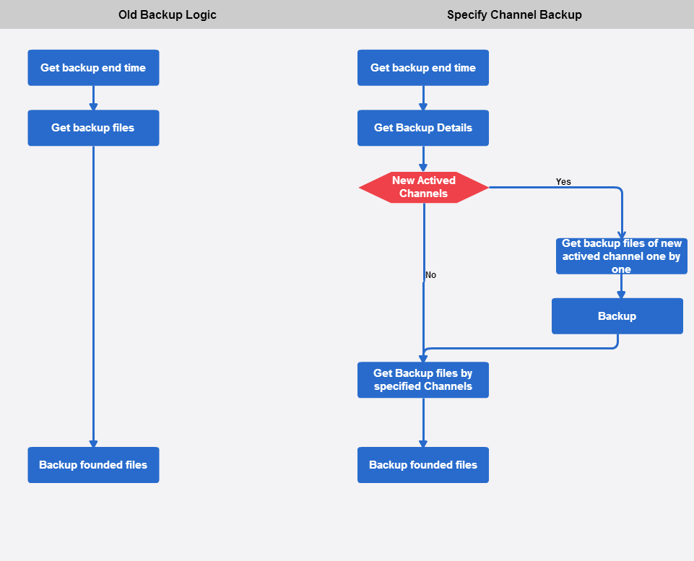

* + - 1. Content Server
         * Read an video, audio or image file

Nothing should be change.

* + - * + FS Trimming

When free space on client local file system is not enough, trimming will happen.

Impacted class: DataTrimmer, ScheduledTrimTimer

Current functionality:

For ESS client trimming:

First trim files already backup on ESS

Second do scheduled trimming

Third do emergency trimming

For ESS server trimming:

There is a timer by default which trim files both on client and destination before maximum storage days (configurable, 365 days). It will also delete related records in videos, transcodVideos, and eventsIndex table.

To do:

For ESS client trimming:

In first step ‘trim files already backup on ESS’, trim video, audio and image files by backup channels.

First trim half data files of specified channel, and then check whether free space is enough, if yes exit trim. If not, continue trim another specified channel.

In second step ‘schedule trimming’,

For ESS server trimming:

Nothing should be change.

* + 1. OpCenter could choose connect to CS or ESS to playback videos
       1. OpCenter

In OpCenter Preferences dialog, we add a checkbox “Playback from Extended Storage Server”, please see below GUI:

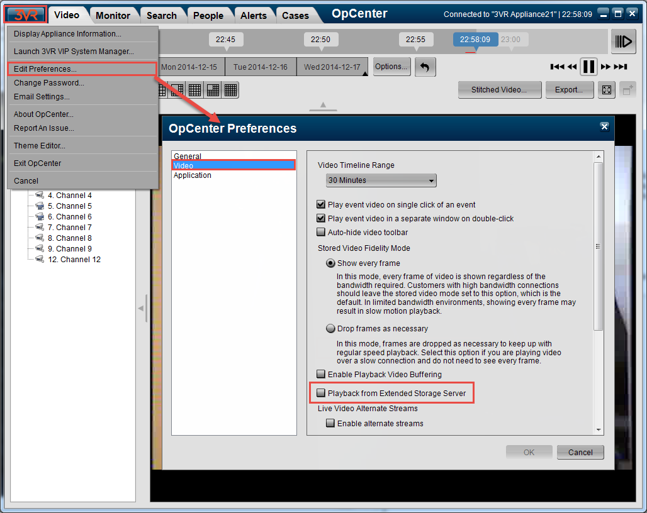

* + - * + Force OpCenter connect to ESS

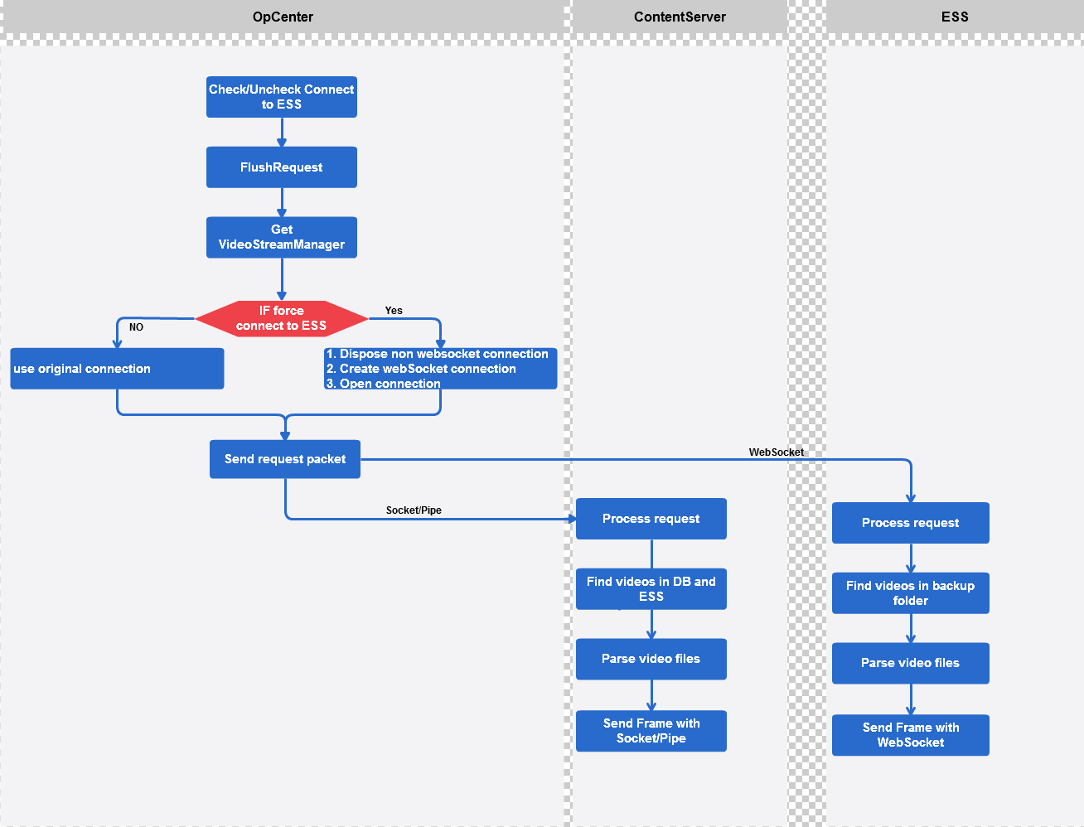

1. DATA DESIGN

We need a new table for the details about specified channels, because maybe some channels are not specified at the same time.

ChannleId: primary key, it is use to indicate specified channel.

IsActive: it is use to indicate whether continue backup this channel’s data.

BackupEndTime: the latest backup video file timestamp of this channel. It is used to indicate whether this channel is new added.

If its value is less than the EndTime of BackupSummary that is means this channel is new added.

|  |  |  |
| --- | --- | --- |
| **BackupDetails** | | |
| ChannelId | IsActive | BackupEndTime |
|  |  |  |
|  |  |  |

1. HUMAN INTERFACE DESIGN

N/A

1. REQUIREMENTS MATRIX

N/A

1. Error Conditions

N/A

1. APPENDICES

N/A